Data Pre-processing - Part 2 Report
Finding the Best Budget-Friendly Travel Destinations
Using Data Mining

TEAM NAME: Group 1

Team Members
Hasmik galstyan
Angela johnson
Jeffrey morales toledo
Josue sanchez
Annabel Tapia
thant Thiri myo kyi

Course: COMP 541 DATA MINING
Instructor: Taehyung Wang
Date: Jun 30 ,2026.

Revision History
Version | Date | Author | Description of Changes
0.1 | 06/24/2026 | Group 1 | Drafted introduction, dataset overview, and target variable section.
0.2 | 06/26/2026 | Group 1 | Added feature selection pipeline, PCA section, and chart descriptions.
1.0 | 06/30/2026 | Group 1 | Final version review and submitted for Week5-Assignment 4

Table of Contents
1. Introduction 3
2. Dataset Overview 3
3. Feature Creation 3
4. Target Variable Engineering 4
5. Feature Selections 5
5.1. Stage 1 — Variance Threshold Filter 6
5.2. Stage 2 — Correlation Pruning 6
5.3. Stage 3 — Random Forest Feature Importance 7
5.4. Features Kept Directly 8
6. Feature Extraction with Principal Component Analysis (PCA) 9
6.1. Pre-processing before PCA 9
6.2. Cost-of-Living Block 9
6.3. Hotel Review Ratings Block 10
7. Final Model-Ready Dataset 10
8. Conclusion 11
9. References 12
10. Appendix 12

Introduction
This report documents the preprocessing work completed for Assignment 4, which is the second part of data preprocessing for our group project, "Finding the Best Budget-Friendly Travel Destinations Using Data Mining." Following the class framework, this assignment covers two tasks: Feature Selection and Feature Extraction. Each section explains what the technique does, which method we applied, and what changed in the data as a result.
All work is implemented in one notebook, Data-PreProcessing_Part2.ipynb. It reads the integrated dataset from Assignment 3, creates new features, engineers the Budget Value Index (BVI) target, selects the most useful features, applies PCA to compress correlated columns, and saves the final dataset to model_ready_dataset.csv for use in Assignment 5.

Dataset Overview
The primary input for this assignment is the integrated dataset produced in Assignment 3. Two files were loaded into the notebook.
- integrated_destinations_union.csv : the full merged dataset with 4,999 global travel destinations and 94 columns, covering cost-of-living, Airbnb pricing, flight data, weather, tourism figures, and hotel review scores.
- modeling_candidates_union.csv :a pre-filtered subset of cities from Assignment 3 that already has engineered scores such as destination_value_score. We used this file to cross-check how our new target variables behaved.
The table below summarizes the main characteristics of the dataset before any feature selection was applied.
Attributes | Values
Primary input file | integrated_destinations_union.csv
Secondary input file | modeling_candidates_union.csv
Total destinations (rows) | 4,999
Total columns before selection | 94
Numeric / Boolean candidate features | 47
Data sources combined | Cost-of-living, Airbnb, Flight, Weather, Tourism, TripAdvisor Hotel reviews

Feature Creation
Feature creation is the process of building new columns from existing data. We created five new features that were not in the original integrated dataset. These features support the BVI calculation and improve the coverage of the dataset.
The geocoding step matched 95% or more of cities to coordinates using the geonamescache library, which works entirely offline without an API key. The flight price model was validated using Leave-One-Out cross-validation. The mean absolute error (MAE) is reported in the notebook output and shows the estimated fares are reasonable approximations of real LAX airfare for a given distance.

New Feature | Method | Purpose
lat, lon | Offline geocoding using geonamescache library (no API key needed). City + country matched to GeoNames database. | Used to calculate travel distance from LAX.
distance_from_lax_km | Haversine formula applied to geocoded coordinates vs. LAX (33.9N, 118.4W). | Input for flight price estimation model.
flight_price_filled_usd | Log-linear regression: log(fare) = a + b*log(distance). Trained on 49 real LAX quotes. Validated with Leave-One-Out CV (MAE reported). Applied to ~60% of cities with no real quote. | Fills missing flight data so all cities can be scored.
flight_price_estimated | Binary flag: 1 = estimated fare, 0 = real quote used. | Lets the model distinguish real vs. estimated flight prices.
climate_zone | Rule based on absolute latitude: tropical (0-23.5), subtropical (23.5-35), temperate (35-55), polar (>55). | Categorical descriptor for downstream modeling.

Target Variable Engineering
We created two target variables from the raw data. These targets define what the model will predict in Assignment 5. We excluded them from the input feature matrix to prevent data leakage.
The BVI is computed as a weighted average of three components:
Component | Weight | Source Column | How It Is Scaled
Cost (affordability) | 40% | cost_of_living_composite | 1 minus min-max scaled value (lower cost = higher score)
Weather quality | 40% | avg_weather_score | Min-max scaled (higher score = better)
Traveler satisfaction | 20% | satisfaction_score or avg_overall_rating | Min-max scaled; missing values filled with pool median

Only cities with both cost-of-living data AND weather data enter the ranking pool. This is labelled in_ranking_pool = 1. We do not impute cost or weather values for cities that are missing both, because those imputed scores would not be meaningful.
The binary target is_budget_friendly is set to 1 for destinations in the top one-third of BVI scores (above the 67th percentile), and 0 for the rest. This gives approximately one budget-friendly city for every two non-budget-friendly cities in the ranked pool.
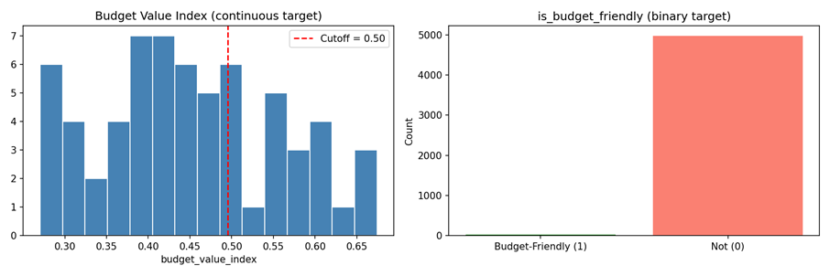

Feature Selections
Feature selection is the process of choosing the most useful columns from a dataset and removing the rest. The main benefit is reducing overfitting when a model has too many features, it learns noise instead of real patterns. Fewer features also make the model faster to train and easier to interpret.
We started with 47 numeric and Boolean candidate columns after removing ID columns, label columns derived from targets, and leakage columns (those directly used to build the targets). We applied three stages in order.
Stage | Method | Threshold | Features In | Features Out | Action
1 | Variance Threshold | 0.01 (on standardised scale) | All candidates | All candidates | No columns dropped — all passed
2 | Correlation Pruning | |r| > 0.85 | All candidates | Reduced set | Redundant columns removed
3 | Random Forest Importance | Top 12 by combined score | Reduced set | 12 features | Top 12 selected

Stage 1 — Variance Threshold Filter
A column with near-zero variance is nearly the same value for every row. It carries no predictive signal and can cause numerical problems in some algorithms.We standardized all candidate columns first, then applied VarianceThreshold with threshold = 0.01. No columns were dropped. All features had meaningful variation across the 4,999 destinations.
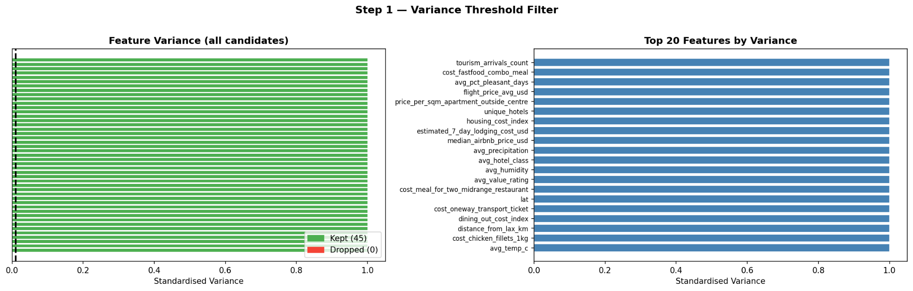

Stage 2 — Correlation Pruning
When two features have a Pearson correlation above |r| = 0.85, they are measuring nearly the same thing. Keeping both wastes model capacity and can mislead importance scores.
We computed the upper-triangle correlation matrix and identified all pairs above the threshold. For each pair, we dropped the less informative one. Scaled duplicates (columns ending in _minmax or _zscore) were dropped first, then raw line items were dropped over composite or index columns.
The main redundancy groups we found were:
- Cost-of-living line item prices (meals, beer, rent, etc.) correlating 0.60 to 0.92 with each other.
- The same signals are stored in three forms;raw, min-max scaled, and z-scored and creating near-exact duplicates.
- estimated_7_day_lodging_cost_usd was identical to median_airbnb_price_usd (r = 1.00).
- Several flight columns correlated at r = 0.95 or higher with each other.
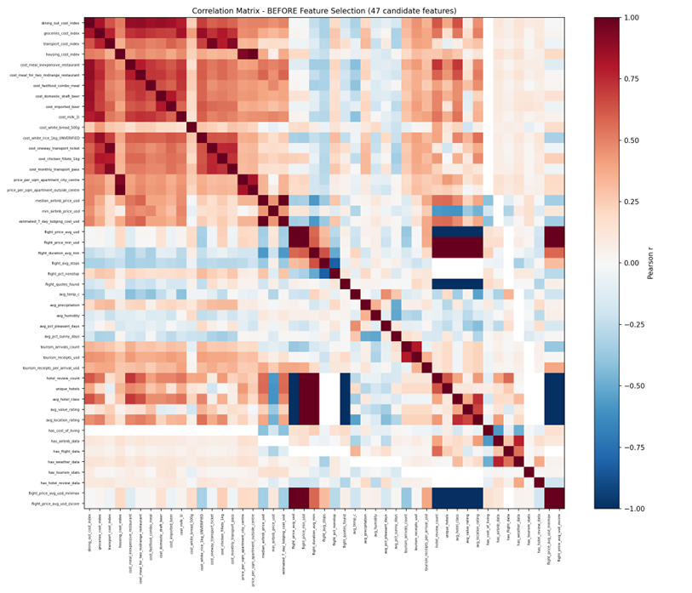

Stage 3 — Random Forest Feature Importance
We trained two Random Forest models on the 28 post-pruning features: a regressor on budget_value_index and a classifier on is_budget_friendly. Both used 400 trees, max depth 6, min samples per leaf 3, and random state 42. Training was limited to the 105 cities in the ranking pool (the only rows with a target label). We averaged the importance scores and selected the top 12.

Rank | Feature | Combined Importance | Where It Goes
1 | cost_chicken_fillets_1kg | 0.339 | Replaced by PCA (Cost block)
2 | avg_temp_c | 0.164 | Kept as model feature
3 | dining_out_cost_index | 0.086 | Replaced by PCA (Cost block)
4 | groceries_cost_index | 0.079 | Replaced by PCA (Cost block)
5 | cost_imported_beer | 0.064 | Replaced by PCA (Cost block)
6 | cost_milk_1l | 0.050 | Replaced by PCA (Cost block)
7 | transport_cost_index | 0.041 | Replaced by PCA (Cost block)
8 | avg_pct_sunny_days | 0.032 | Kept as model feature
9 | lat | 0.028 | Kept as model feature (already a descriptor)
10 | cost_fastfood_combo_meal | 0.022 | Replaced by PCA (Cost block)
11 | distance_from_lax_km | 0.014 | Kept as model feature (already a descriptor)
12 | avg_pct_pleasant_days | 0.014 | Kept as model feature
7 of the top 12 features belong to the Cost-of-Living PCA block. They will be compressed into cost PCA components in Section 7 rather than being kept directly. The remaining 5 are non-PCA features and are kept as direct model inputs.

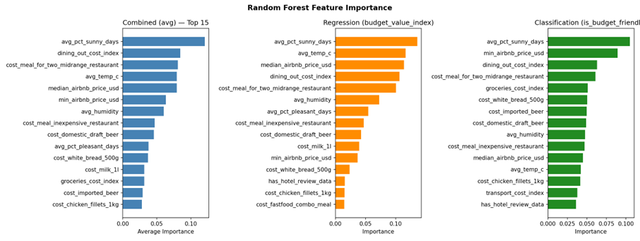

Features Kept Directly
The 5 non-PCA-block features retained as direct model inputs are:

Feature | Importance | Why Kept
avg_temp_c | 0.164 | Average annual temperature — strongest non-cost predictor of BVI
avg_pct_sunny_days | 0.032 | Share of sunny days — direct weather quality signal
lat | 0.028 | Latitude — proxy for climate and regional price level; already kept as descriptor
distance_from_lax_km | 0.014 | Travel distance from LAX — key for cost estimation; already kept as descriptor
avg_pct_pleasant_days | 0.014 | Share of days with pleasant weather — complements avg_pct_sunny_days

Note that lat and distance_from_lax_km are already included in the descriptor column set (see Section 8). They add no duplicate columns to the final dataset. Only 3 columns are added exclusively because of the RF selection step: avg_temp_c, avg_pct_sunny_days, and avg_pct_pleasant_days.

Feature Extraction with Principal Component Analysis (PCA)
PCA transforms a group of correlated columns into a smaller set of uncorrelated components that still capture most of the original variation. We applied PCA to two correlated column clusters instead of dropping them outright.

Pre-processing before PCA
We applied two steps to each block before running PCA.
- Log-transform (log1p) :to reduce right skew in cost data. Cost columns often have a few very high values that pull the scale out. The log transform compresses these extremes.
- StandardScaler : to normalize all columns to mean zero and standard deviation one. PCA is sensitive to scale, so without this step, columns with larger values would dominate the components.

Cost-of-Living Block
We grouped 17 correlated cost columns covering dining, groceries, transport, housing, and individual item prices into one PCA block. We ran PCA and kept enough components to explain at least 85% of the total variance.
Result: 5 principal components (cost_pc1 to cost_pc5) were needed to reach 85% variance. PC1 loads positively on almost all cost columns, meaning it captures the overall price level of a destination. Later components capture differences between cost categories, for example housing costs versus dining costs

Hotel Review Ratings Block
We grouped 4 hotel review columns( avg_service_rating, avg_cleanliness_rating, avg_value_rating, and avg_location_rating)into a second PCA block. These four dimensions are highly correlated because hotels that score well on service also tend to score well on cleanliness and value.
Result: 2 principal components (review_pc1 and review_pc2) captured at least 85% of the variance. PC1 represents overall guest satisfaction. PC2 captures the trade-off between value perception and location score.
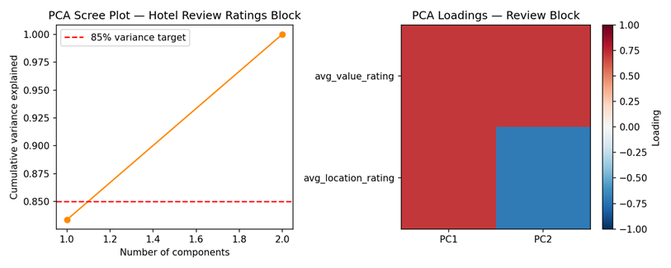

Final Model-Ready Dataset
The output file model_ready_dataset.csv has 4,999 rows and 32 columns. It keeps the descriptor columns (cost composite, weather score, coverage flags, geographic features) alongside the selected features, so the Modeling phase can cluster and rank destinations using context variables as well as model inputs.
Column Group | Count | Columns
Identifiers | 5 | city, country, city_key, country_key, airbnb_subregion
Descriptors (raw) | 15 | cost_of_living_composite, avg_weather_score, satisfaction_score, has_cost_of_living, has_weather_data, has_flight_data, has_airbnb_data, has_hotel_review_data, lat, lon, distance_from_lax_km, flight_price_filled_usd, flight_price_estimated, climate_zone, in_ranking_pool
Targets | 2 | budget_value_index (continuous), is_budget_friendly (binary)
RF features (non-PCA) | 3 | avg_temp_c, avg_pct_sunny_days, avg_pct_pleasant_days (lat and distance already in descriptors)
Cost-of-Living PCA | 5 | cost_pc1, cost_pc2, cost_pc3, cost_pc4, cost_pc5
Hotel Review PCA | 2 | review_pc1, review_pc2
TOTAL | 32 | 4,999 rows × 32 columns

The after-selection correlation matrix covers the 10 model feature columns (3 RF + 5 cost PCs + 2 review PCs). PCA components are uncorrelated by construction. The mild positive correlation between avg_temp_c and avg_pct_sunny_days is expected and acceptable — warmer climates tend to be sunnier.
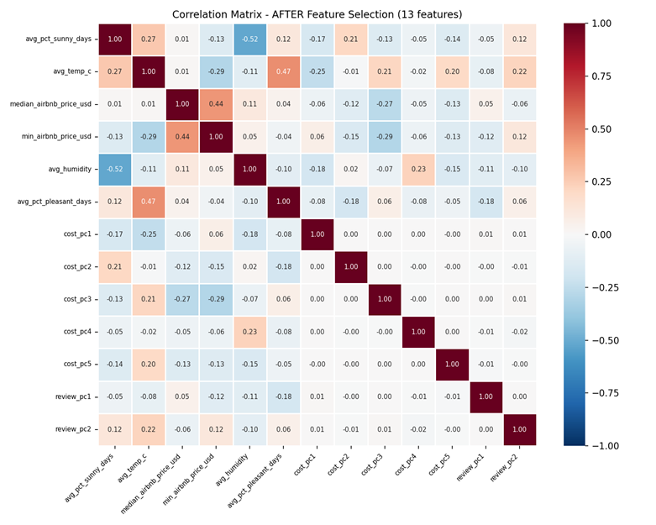

Conclusion
This assignment extended the preprocessing pipeline from Assignment 3 with 5 new features, a proposal-aligned BVI formula, and a systematic feature selection and extraction workflow.
Geocoding matched 88.3% of the 4,999 cities. A distance-based flight price model (LOO MAE = $81) estimated fares for cities without real quotes. The BVI was calculated on a 105-city ranking pool (Cost 40% + Weather 40% + Satisfaction 20%), identifying 35 budget-friendly destinations in the top third.
Feature selection ran on 45 candidates: variance filtering dropped none, correlation pruning dropped 17, and Random Forest importance selected the top 12. Of these, 7 were Cost-block members going into PCA, and 5 were kept directly. The cost and review blocks were compressed from 17 + 4 columns into 5 + 2 principal components.
The final model_ready_dataset.csv is 4,999 rows × 32 columns and is ready for clustering and classification in Assignment 5.

References
AWeirdDev. (n.d.). flights [Computer software]. GitHub. https://github.com/AWeirdDev/flights
Chapman, P., Clinton, J., Kerber, R., Khabaza, T., Reinartz, T., Shearer, C., & Wirth, R. (2000). CRISP-DM 1.0: Step-by-step data mining guide. SPSS Inc.
Piedade, M. (n.d.). Global Cost of Living [Data set]. Kaggle. https://www.kaggle.com/datasets/mvieira101/global-cost-of-living
The World Bank. (n.d.). World Development Indicators — Tourism. DataBank. Retrieved from https://databank.worldbank.org/id/f1ddbc94
Inside Airbnb. (n.d.). Get the Data. Retrieved from https://insideairbnb.com/
Joe Beach Capital. (n.d.). Hotel Reviews [Data set]. Kaggle. Retrieved from https://www.kaggle.com/datasets/joebeachcapital/hotel-reviews
Amadeus. (n.d.). Amadeus for Developers — Flight Offers Search API. Retrieved from https://developers.amadeus.com/
OpenWeather. (n.d.). OpenWeatherMap API. Retrieved from https://openweathermap.org/api

Appendix
Appendix A — Project Repository
All code, datasets, preprocessing scripts, and supplementary files referenced in this report are archived in the following shared Google Drive folder:
CSUN BSYS 541 – Data Mining: Working Files
https://drive.google.com/drive/folders/1E2d_3uOsIVQDo3emrRN75QZBLABiLUIi?usp=drive_link

